

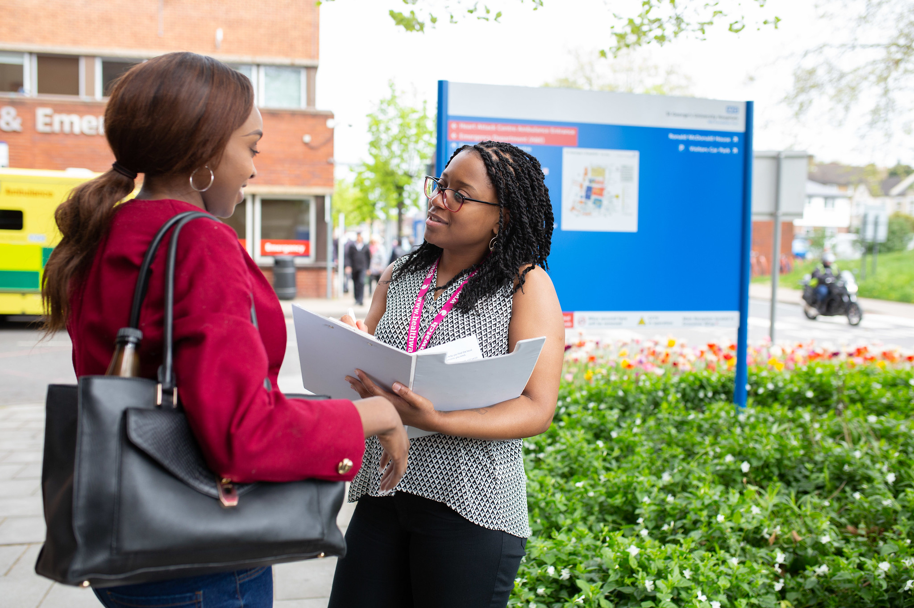

Cardiovascular Disease Awareness and Prevention Focus Group

[
Enter
sub
-
heading
]

Contents

Introduction 2
Key Findings 4
Recommendations 7
Conclusion 8
Next Step 9

Introduction

Background
Cardiovascular disease (CVD) remains one of the leading causes of death and long-term illness in the UK and is a significant contributor to health inequalities. Conditions such as heart disease and stroke are strongly associated with preventable risk factors including high blood pressure, high cholesterol, diabetes, smoking, poor diet, and physical inactivity. These risks are often compounded in areas experiencing deprivation, where access to timely healthcare, health information, and preventative services can be uneven.
In Newham, the population is diverse, with many residents facing additional barriers related to language, culture, digital access, and socioeconomic circumstances. These factors can result in late diagnosis, reduced uptake of NHS Health Checks, and lower engagement with preventative services. Community based approaches are therefore essential to improving awareness, supporting early intervention, and reducing avoidable cardiovascular morbidity and mortality.
This report summarises findings from focus group discussions held during Heart Health Day, an event organised by Healthwatch Newham as part of a CVD awareness and prevention project. The day focused on raising awareness of CVD, including the impact of smoking and vaping, and supporting prevention through community engagement. Residents were able to receive free health checks, access practical heart health information, and connect with a range of local health organisations offering advice, support, and referral pathways. The focus groups explored community knowledge, experiences, and perceptions of CVD, as well as views on existing services and ideas for improvement.

Objectives
The focus group aimed to:
- Explore community understanding of cardiovascular disease and its associated risk factors.
- Assess awareness of local CVD prevention, screening, and support services in Newham.
- Understand experiences of accessing GP services and referral pathways.
- Identify key barriers that prevent people from seeking help, attending health checks, or engaging with preventative care.
- Gather community led suggestions on how services and communication can be improved to better meet local needs.

Key Findings

Awareness and Knowledge of CVD
- Most participants reported having some awareness of cardiovascular disease, particularly common risk factors such as high blood pressure and high cholesterol.
- However, the level of understanding varied considerably. While some individuals demonstrated a basic understanding of how lifestyle factors affect heart health, others had limited knowledge and were unsure about symptoms, long term risks, or preventive measures.
- Participants who had attended community initiatives such as the Heart Health Day event reported feeling more informed and confident in understanding CVD. These events played an important role in translating medical information into practical, relatable guidance.

Awareness of Services
- Awareness of local, formal CVD related services in Newham was generally low. Aside from leisure centres, walking groups, and occasional health events, many participants were unaware of structured programmes such as NHS Health Checks or targeted cardiovascular prevention initiatives.
- When participants were aware of services, information was most commonly obtained through GPs, posters in health settings, or community events. Social media was not widely cited, particularly among older adults.

Information Gaps
- Participants consistently stated that there is not enough information available in the community about CVD prevention, treatment, and available support. Existing information was described as difficult to understand, too technical, or not culturally and linguistically accessible.
- Older adults, people with limited English proficiency, and those unfamiliar with digital platforms were seen as particularly at risk of being excluded from important health messaging.

Information Gaps
Several recurring barriers were highlighted across the focus groups:
- Language barriers and difficulty understanding medical terminology.
- Long waiting times for appointments and delays in accessing services.
- Limited consultation time with GPs, leading to rushed discussions.
- Challenges completing online booking systems and digital forms.
- Concerns around cultural sensitivity, including preferences regarding the gender of healthcare professionals.
These barriers often interacted with one another, contributing to frustration and, in some cases, disengagement from preventative healthcare.

GP Referral Pathway Experience
- Experiences of the GP referral process were mixed. Many participants reported finding the process confusing, particularly when unfamiliar medical language was used or when referrals relied heavily on digital systems such as the NHS App.
- Older adults and those with limited digital skills felt particularly disadvantaged. While referral times were generally seen as reasonable, participants expressed a need for clearer explanations, written follow up, and more consistent support especially for individuals with long term or high-risk conditions.

Service Experience and Examples of Good Practice
- Most participants reported feeling listened to and respected by healthcare professionals, though some felt that appointments were too short to fully discuss concerns. Overall, GP services were viewed positively but with clear room for improvement in responsiveness and communication.
- Community based health events offering blood pressure checks and lifestyle advice were consistently highlighted as examples of good practice. These events were seen as accessible, approachable, and effective in raising awareness and encouraging engagement.

Recommendations
Based on the focus group findings, the following recommendations are proposed:
- Increase community outreach through regular, locally delivered CVD awareness events in accessible venues.
- Improve communication of GP referral pathways by using plain language explanations, visual aids, and verbal follow up where possible.
- Address digital exclusion by offering non digital booking routes and support with online forms.
- Expand successful community health events, particularly those offering on the spot checks and practical advice.
- Ensure culturally sensitive service delivery, including consideration of language needs and gender preferences.
- Strengthen partnerships with community groups, faith organisations, and local leaders to co design and co deliver initiatives.

Conclusion
The findings demonstrate that while there is a baseline awareness of cardiovascular disease within the community, significant gaps remain in knowledge, service visibility, and accessibility. Structural barriers such as language, time constraints, cultural factors, and digital exclusion continue to prevent many individuals from engaging with preventative services.
Community based, culturally responsive approaches have proven effective and are valued by participants. By building on these strengths and addressing identified barriers, there is a clear opportunity to improve early detection, prevention, and long-term cardiovascular health outcomes in Newham.

Next Steps
To build on the insights gathered, the following next steps are recommended:
- Share findings with commissioners, GP practices, and voluntary sector partners.
- Pilot enhanced outreach and screening initiatives in priority communities.
- Develop multilingual, easy read, and culturally tailored CVD information materials.
- Review GP referral and follow up processes with a focus on patient understanding and support.
- Continue gathering community feedback to inform service improvement and future engagement.



Reflection on the Heart Health Day Event
18 December 2025 | 11:00am – 2:00pm
2 Gerry Raffles Square, Stratford E15 1BG
The Heart Health Day was a meaningful and well-attended community event focused on promoting cardiovascular health, with particular attention given to the risks of vaping and smoking among young people. Held in the heart of Stratford, the event successfully created an engaging, informative, and supportive environment for local residents.
The partnership between West Ham United Foundation, well Newham, South PCN, Sphere Support, and Healthwatch Newham brought together a wide range of expertise and resources, enabling a holistic approach to health promotion. The services offered including free blood pressure checks and smoking cessation support were practical, accessible, and clearly aligned with the needs of the local community.
One of the most significant outcomes of the event was the health screening activity. Of the twelve individuals who received health checks with Sphere support team, one person was identified as having high blood pressure. She was advised to contact her GP and to purchase a blood pressure monitor for regular home monitoring. This timely intervention has the potential to be lifesaving and clearly demonstrated the importance of early detection and accessible community-based health services.
Beyond health checks, the event placed strong emphasis on listening to the community. Attendees were encouraged to share their experiences and views to help shape local health services, reinforcing a genuine commitment to co-producing solutions with residents. The provision of a £10 voucher recognised participants’ time and contributions and helped facilitate open and meaningful conversations.
The focus on young people and vaping was particularly timely. With growing concerns around vaping among youth, providing clear, evidence-based information alongside cessation resources was essential. The interactive nature of the event made these messages more engaging and impactful than traditional methods such as leaflets or online campaigns.
Offering refreshments and a light lunch helped create a welcoming and informal atmosphere, encouraging attendees to stay longer, engage in conversations with health professionals, and connect with local organisations. This contributed to a strong sense of community and shared responsibility for heart health.
On a personal level, it was inspiring to see residents engage so openly asking questions, seeking advice, and taking proactive steps such as arranging follow-up appointments or accessing cessation support. This reinforced the value of delivering health initiatives in familiar community spaces where people feel comfortable and empowered.
Overall, the Heart Health Day was a strong example of collaborative, community-centred health promotion. It delivered immediate benefits to attendees while also strengthening relationships between local organisations and residents an essential foundation for improving long-term cardiovascular outcomes in Newham.
Author: Safiya (Student Nurse Volunteer)








Healthwatch Newham

Stratford Advice Arcade

107-109 The Grove

London

E15 1HP

www.healthwatchnewham.co.uk

0800 056 4293

info@healthwatchnewham.co.uk

Facebook.com/HealthwatchNewham

@HW_Newham

@Healthwatch_Newham

Healthwatch Newham

